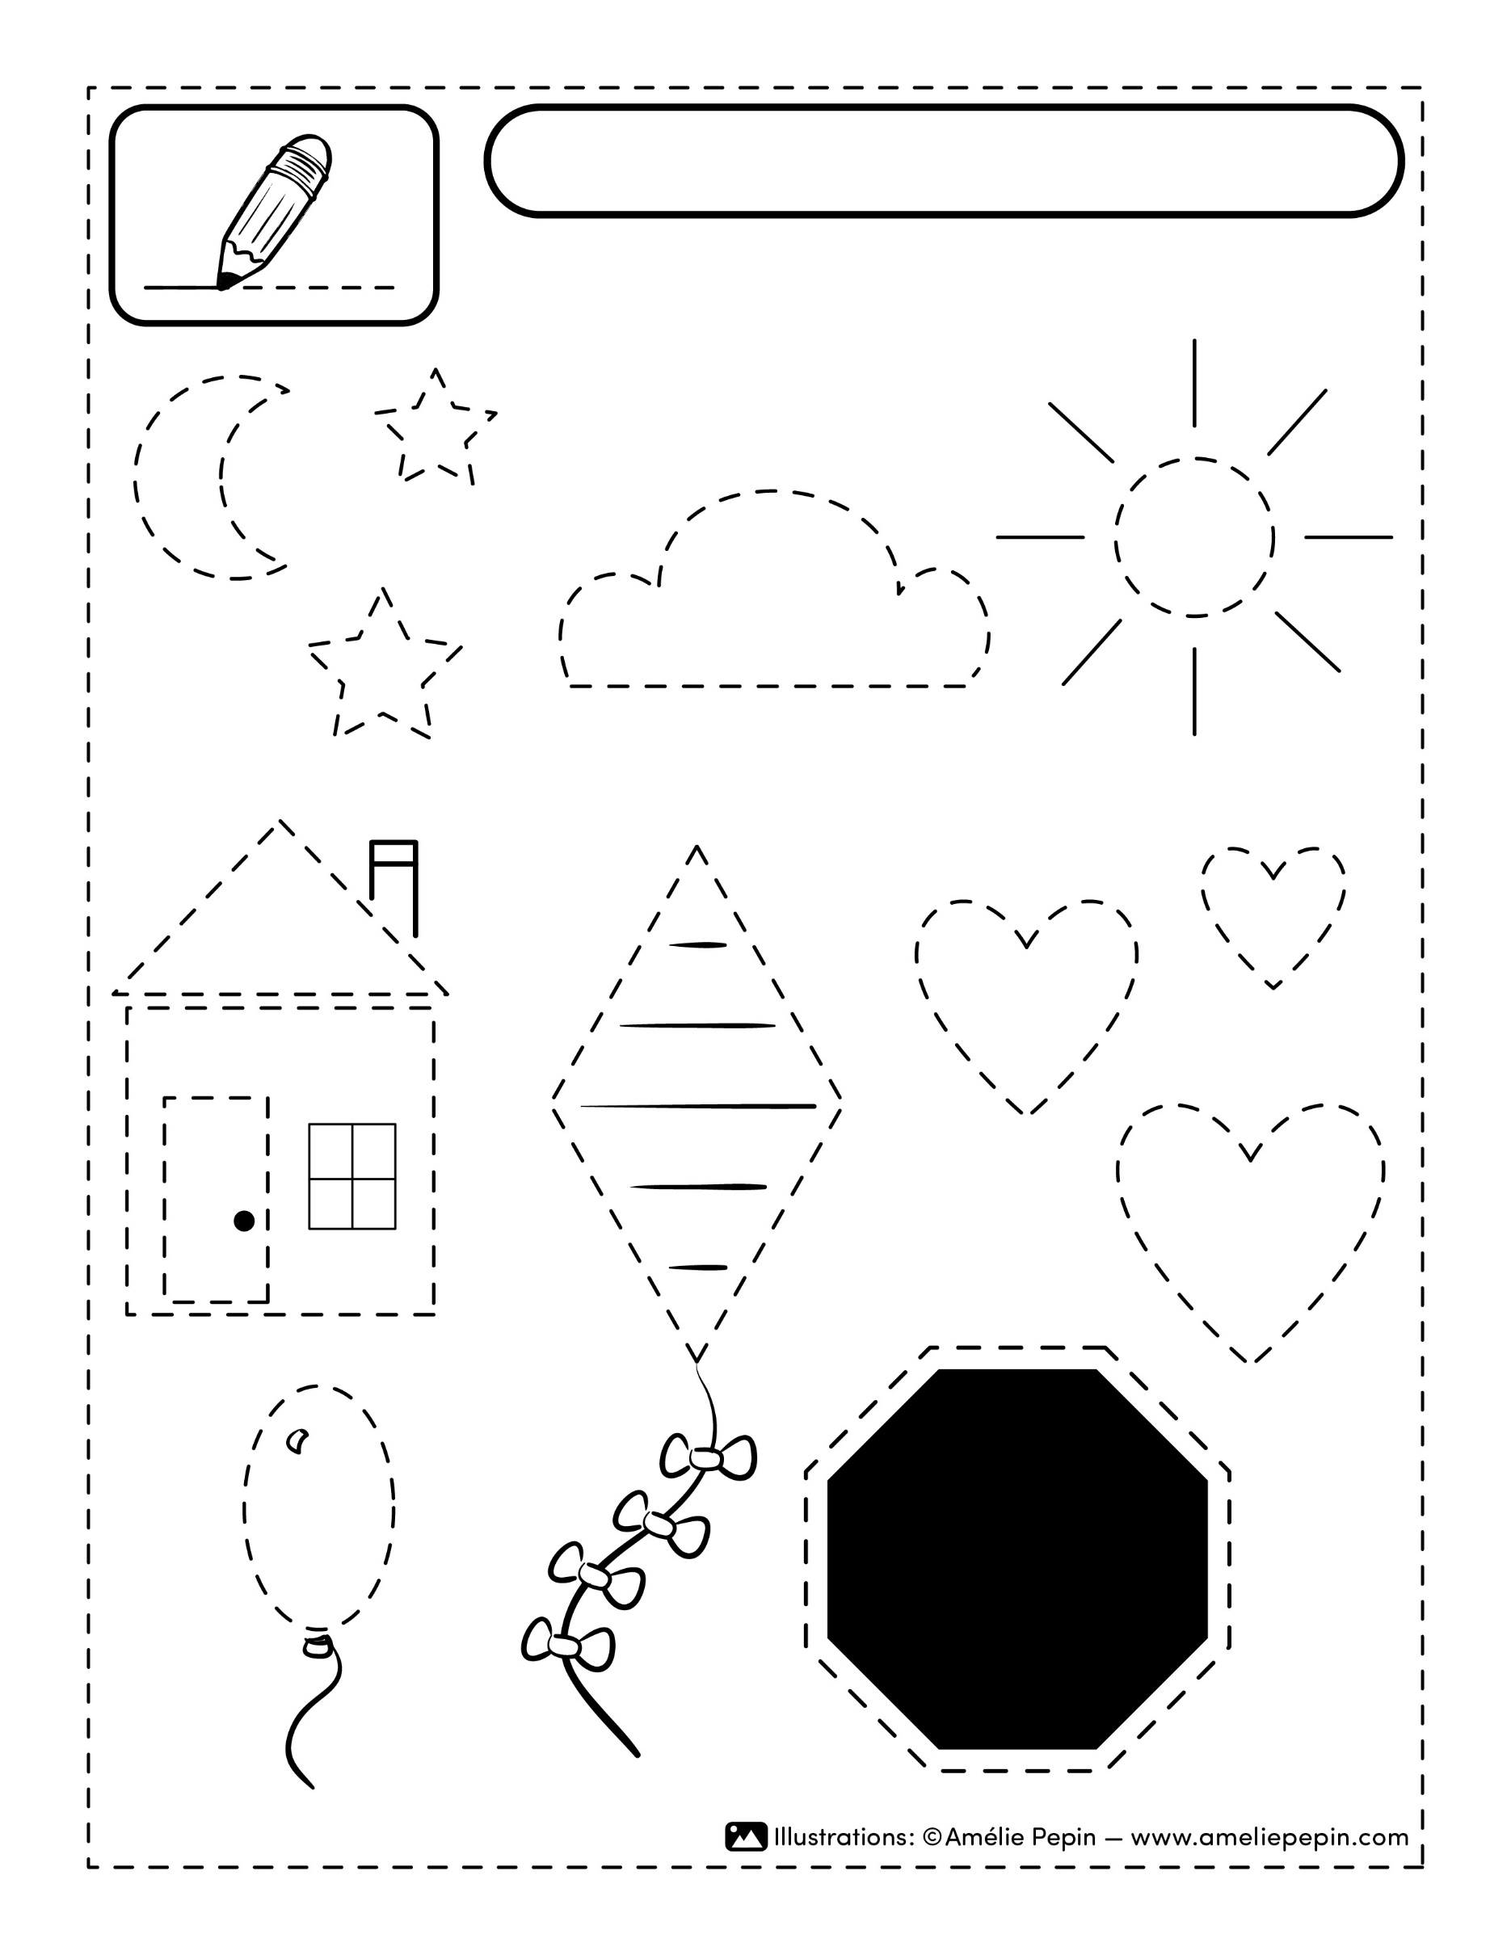
STOP
Your text here.
Name :

