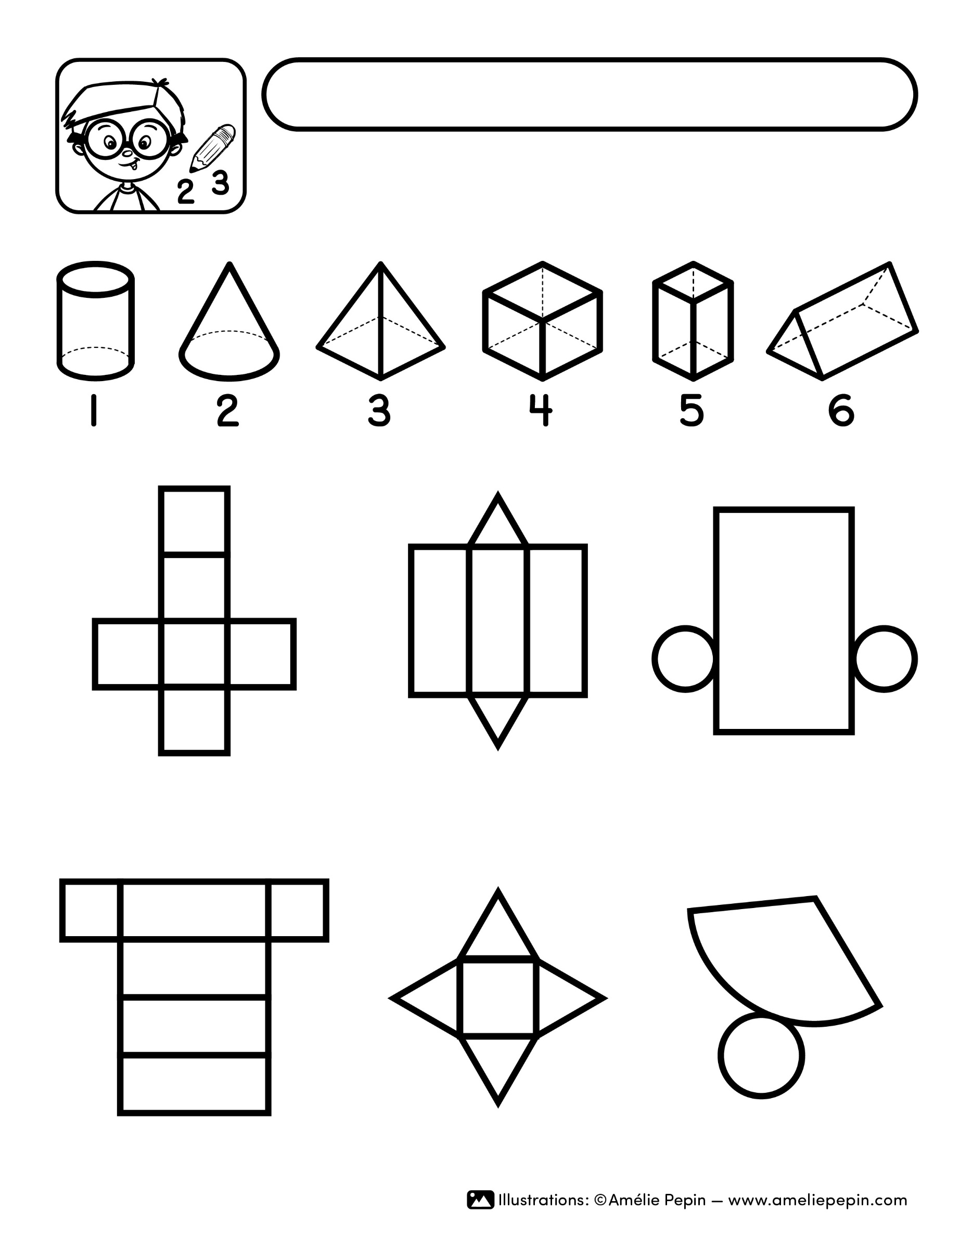
Solid: ____
Solid: ____
Solid: ____
Solid: ____
Solid: ____
Solid: ____
Your text here.
Name :

