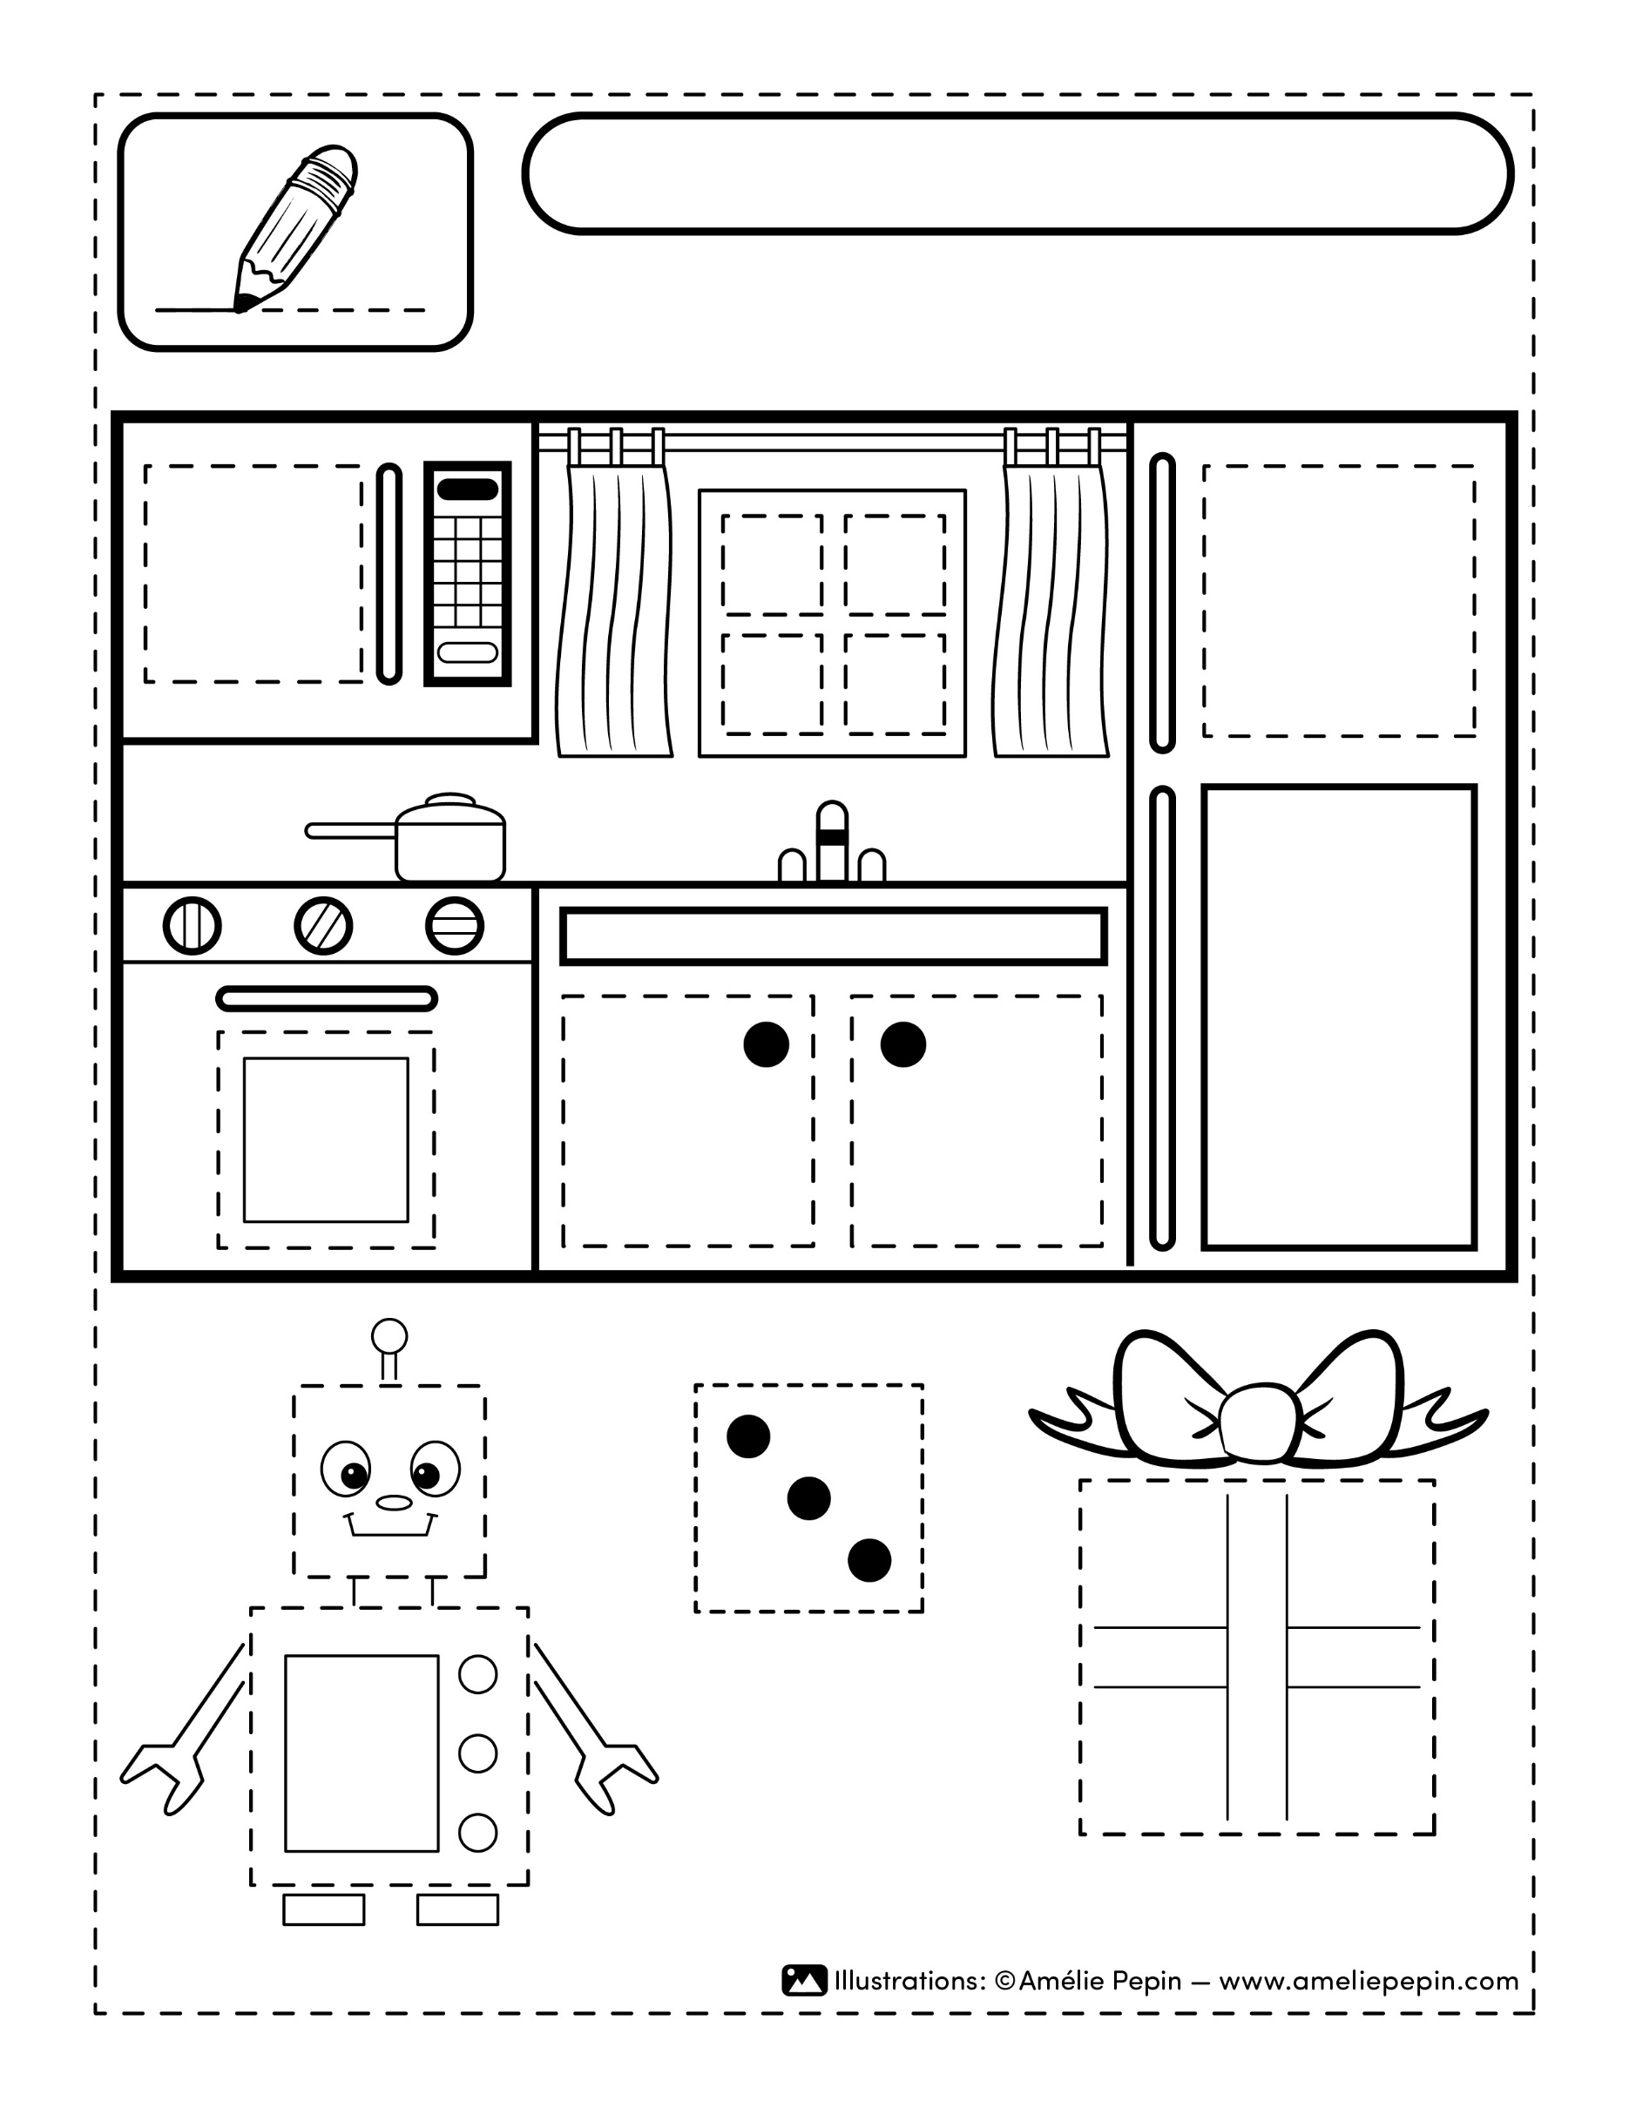

Your text here.

Your text here.

Your text here.

Your text here.

Name :